ULTRASONIC SENSOR
ASSINGMENT-4

BY
P.MARITHURAICHI
952319104028

ULTRASONIC SENSOR

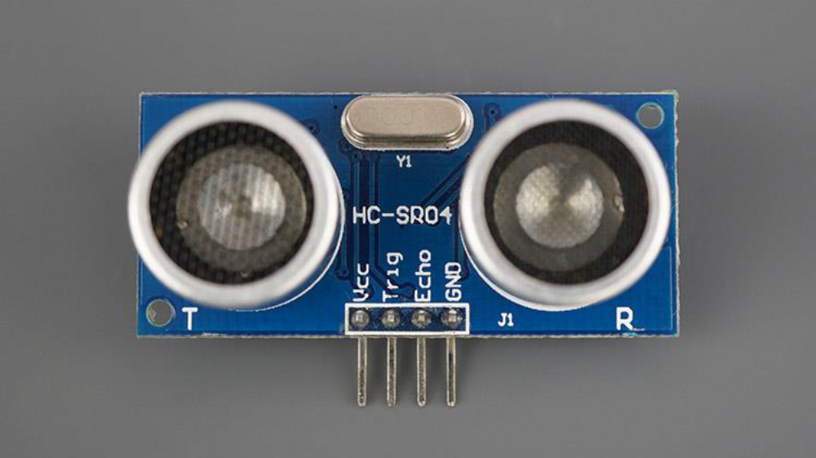

CODING
#define TRIGGER_PIN 11
#include <NewPing.h>
#define ECHO_PIN 12
#define MAX_DISTANCE 200
// NewPing setup of pins and maximum distance
NewPing sonar(TRIGGER_PIN, ECHO_PIN, MAX_DISTANCE);
void setup() {
Serial.begin(9600);
}
void loop() {
delay(50);
unsigned int distance = sonar.ping_cm();
Serial.print(distance);
Serial.println("cm");
}
DISTANCE MEASUREMENT

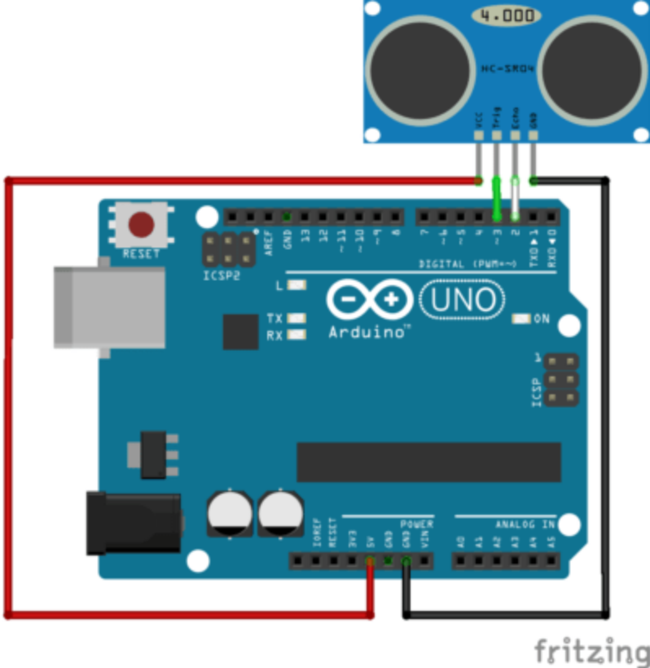

Material
• Computer
• Arduino UNO
• USB cable to connect Arduino to the computer
• Ultrasonic distance sensor HC-SR04

UPLAD DOCUMENT
File Backend Image
• To upload a file backend image with IBM® Cloud Infrastructure Center UI, follow these steps:
1. On the Images page, select Create.
2. On the pop-up window, specify the following items:
o Image name
o Operating system
o Image disk type ( choose SCSI )
o Image Source ( choose FILE )
o Disk Format
8. Click Browse and select the image file on your local system.
9. Select Upload to upload the image.
10. The information and status of uploading images is shown on the Image page. When the status turns Active, it means that the uploading is successful. Other information

including the name of image, operating system, description, and last updated time for the image is displayed.

Snapshot Backend Image
A snapshot is a mechanism that allows you to create a new image from a running instance. This mainly serves two purposes:
• As a backup mechanism: save the main disk of your instance to an image and later boot a new instance from this image with the saved data.
• As a templating mechanism: customise a base image and save it to use as a template for new instances.

Follow these steps to get a snapshot in IBM® Cloud Infrastructure Center:
1. On the Virtual Machines page, select a VM which you want to capture.
2. Select the Capture button, a new snapshot backend image would be generated when this step finished successfully.
v

